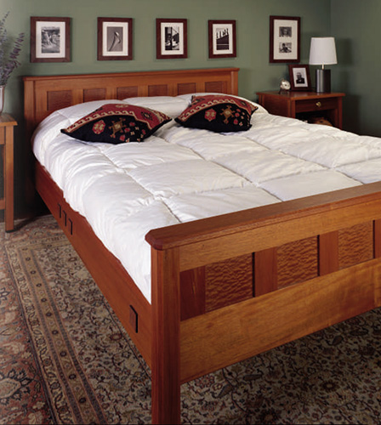

With a look that combines traditional detailing and construction with the clean lines of contemporary style, our anniversary bed is sure to be the ideal centerpiece for just about any bedroom decor. Like the entire POPULAR MECHANICS anniversary furniture series, it's constructed of solid mahogany, and has a clear finish so it will age gracefully to a deep, warm glow. The design is based on time-honored frame-and-panel construction, with convenient rail hangers so the bed can be easily disassembled. Decorative accents of pomele sapele veneer and dark wenge give our bed a touch of distinction while tying it to the other pieces in the series. These exotic woods are available from mail-order suppliers such as A&M Wood Specialty Inc., 358 Eagle St. N., Box 32040, Cambridge, Ontario, Canada N3H 5M2; www.amwoodinc.com.
The bed is built with a series of support slats that eliminate the need for a box spring, and the dimensions we show will handle a queen-size mattress. While mattresses vary in thickness, one that's 8 in. thick will yield a 19-1/2-in.-high bed. For a mattress of a different size or thickness, simply adjust the dimensions as necessary.
Page 1 2 3 Next »

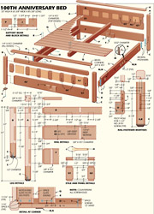  Click to Enlarge |  | MATERIALS LIST--BED  Key No. Size and description (use)  A 2 2-1/2 x 2-1/2 x 31-1/4" mahogany (post)  B 2 2-1/2 x 2-1/2 x 21-1/4" mahogany (post)  C 4 3/4 x 2-1/2 x 2-1/2" wenge (foot)  D 2 1-1/8 x 3 x 60-7/8" mahogany (top rail)  E1 1 1-1/8 x 6 x 60-7/8" mahogany (bottom rail)  E2 1 1-1/8 x 6-3/4 x 60-7/8" mahogany (bottom rail)  F 1 1-1/8 x 6-3/4 x 60-7/8" mahogany (mattress rail)  G1 4 1-1/8 x 3-1/8 x 6-1/2" mahogany (end stile)  G2 10 1-1/8 x 3-1/8 x 6-1/2" mahogany (stile)  H 12 1/2 x 5-3/4 x 7" plywood  I as reqd. pomele sapele veneer  J 2 1-1/2 x 3-1/2 x 8" poplar (support block)  K 2 1 x 3-1/2 x 65-3/8" mahogany (cap)  L 2 1-1/8 x 6-3/4 x 79-3/8" mahogany (side rail)  M 10 3/16 x 2 x 2" wenge (panel)  N as reqd. pomele sapele veneer  O 2 1-1/2 x 3-1/2 x 79-1/4" poplar (support rail)  P 1 1-3/4 x 3-1/2 x 80-3/4" poplar (support beam)  Q 16 3/4 x 4-3/8 x 60-5/8" poplar (slat)  R as reqd. 1-1/2" No. 8 fh woodscrew  S 4 2" No. 8 fh woodscrew  T as reqd. 2-1/4" No. 8 fh woodscrew  Misc.: 5" bedrail hangers, No. 125-062, available from Woodworker's Supply, 1108 N. Glenn Rd., Casper, WY 82601; 800-645-9292; glue; 120-, 220-, 320-grit sandpaper; 4/0 steel wool; Waterlox Original Sealer/Finish (Waterlox Coatings Corp., 9808 Meech Ave., Cleveland, OH 44105).
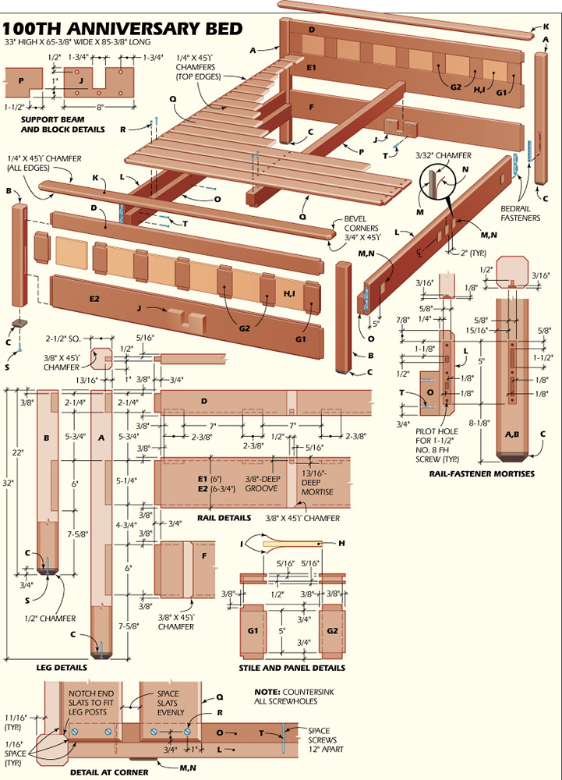
Posts And End Frames
Rip and crosscut the posts to size. If you can't find 3-in.-thick mahogany, glue up blanks from thinner stock. Cut the wenge blocks to size, bore and countersink a screwhole in each, and use glue and screws to fasten them to the posts. Then, cut a 1/2-in., 45° bevel around the bottom of each wenge foot (Photo 1).
Next, lay out the locations of the mortises in the posts for the rail tenons and bedrail hangers. Rout the rail-tenon mortises with a 1/2-in. spiral up-cutting bit and edge guide (Photo 2). Make two or three passes to prevent overheating the bit. Square the mortise ends with a sharp chisel.
Note that the mortises for the bedrail hangers have deep recesses to accommodate the hanger hooks. First, rout these deeper portions with a 1/4-in. bit. Square the ends and switch to a 5/8-in.-dia. bit to rout the shallow portions. Again, square the ends and test fit the hanger plates (Photo 3). Bore pilot holes for mounting the plates, but don't install them yet. Use a 45° chamfer bit in the router table to cut the 3/8-in. chamfers on the long edges of each bedpost (Photo 4).
Rip mahogany stock to width for the headboard and footboard rails and stiles. Crosscut the rails to length, but leave the stile stock in long blanks at this time. Set aside one blank for the outside stiles that have a panel groove on only one edge. Mount a dado blade in your table saw and adjust the fence to cut a centered groove in the edge of the stock. Clamp a plywood auxiliary table to the saw table. Raise the dado blade through the plywood to yield a zero-clearance opening around the blade, and screw a featherboard to the table to keep the stock tight against the rip fence. Then, cut the panel grooves in the edges of the rail and stile stock as required (Photo 5).
Next, crosscut the stiles to finished length, and use the dado blade to cut the rail and stile tenons. Clamp a scrap board to the table saw rip fence to use as a stop (Photo 6). Readjust the blade height to cut the tenon shoulders on the rail ends. Note that the outside stiles on both the headboard and footboard have haunched (notched) tenons. Finally, rout the stile mortises in the rail grooves, square the ends with a chisel and test fit the tenons.
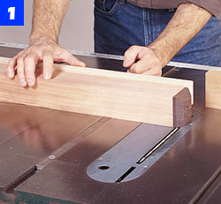
After attaching each wenge foot to a post with glue and a screw, use your table saw to chamfer the edges.
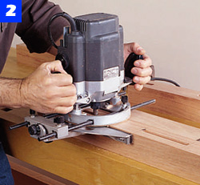
Lay out the mortise positions in the posts, and use a router with a straight bit and edge guide to cut the joints.
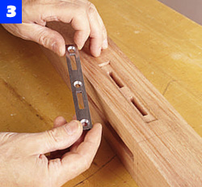
Rout the mortises in the posts for the rail-hanger hardware. Then, test the fit and bore screw pilot holes.
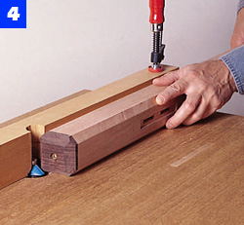
Use a chamfer bit in the router table to shape a 3/8-in. chamfer along the long edges of each bedpost.
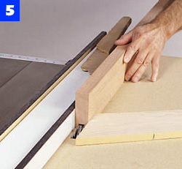
Use a dado blade to cut the grooves in the rails and stiles. A featherboard holds the stock against the fence.
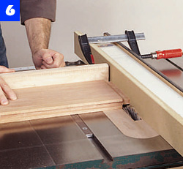
Clamp a scrap board to the rip fence to act as a stop when cutting the tenons on the ends of the rails and stiles.
Veneering The Panels
We used birch-veneer plywood as the core for our veneered panels, but any hardwood-veneer panel will be fine. Be sure to orient the grain on the core stock so it's 90° to the face veneers. Since the finished panels are small, prepare two large panels, then cut the smaller panels from them.
Use a straightedge guide and veneer saw to cut the veneer sheets to size (Photo 7). Make a series of light passes--don't try to cut all the way through with one pass, since the veneer can tear or split.
Next, cut the core stock to the exact size of the veneer sheets and prepare 3/4-in.-thick cauls of scrap plywood that are also this size. Finally, cut sheets of wax or kraft paper to separate the panels and cauls.
Use a foam roller to spread glue onto one surface of each core panel, and then invert each core onto a veneer sheet. Coat the exposed face with glue and place another sheet of veneer on that surface. Arrange the panels in a stack with paper sheets between them as well as on the top and bottom. Place the stack between the cauls and apply clamps from the center toward both ends (Photo 8).
After 2 hours, remove the clamps and place the panels so air can circulate around all sides. The next day, cut the panels to finished size and sand the faces to 220 grit. Use a chamfer bit in the router table to shape the specified edges of the head- and footboard rails.
Assembly And Finishing
Starting with the footboard, spread glue in the bottom-rail mortises and matching stile tenons. Join the pieces and slide the panels into place (Photo 9). Apply glue to the top-rail mortise-and-tenon joints, position the rail and clamp the assembly. Repeat the procedure for the headboard.
Make the beam-support blocks and fasten them to the headboard and footboard rails with glue and screws (Photo 10). Apply glue to the post mortises and rail tenons and assemble the headboard and footboard. Make headboard caps from 1-in.-thick stock, sand to 220 grit and glue them to the top-rail edges.
Mark the hanger mortises on the rail ends and rout away most of the waste. A thick board clamped to the end of each rail helps support the tool (Photo 11). Square the ends and use a small chisel to cut the deeper recesses required to accommodate the hangers. Chamfer the long rail edges.
Make the square rail panels by gluing veneer to a 3/16-in. wenge strip and cutting the panels from that piece. Mark each panel's position and glue it in place. Let the glue set for 20 to 30 minutes, and then remove any excess. Fasten the poplar slat-support rails to the mahogany rails (Photo 12). Note that the support rails are 1/8 in. shorter than the main rails. Attach the support rails with a 1/16-in. setback at the ends. Then install the bedrail hangers.
To assemble the bed frame, engage the rail hangers with the plates on the bedposts. Press down firmly on the rails to be sure that the hooks lock into place. Next, make the central slat-support beam and install it in the support blocks (Photo 13). Cut the bed slats from 3/4-in.-thick poplar, chamfer the top edges and bore the screwholes in the slats. Make sure that the bed frame is square and screw the slats to the support rails and beam (Photo 14).
To finish, disassemble and sand to 220 grit. Then apply a coat of Waterlox Original Sealer/Finish with a brush or rag. Let the finish soak in for about 30 minutes. Use a lintfree cotton cloth to wipe off the excess and let the material dry overnight. Lightly scuff the wood with 320-grit sandpaper, remove the dust and apply at least two more coats in the same way. Burnish the wood with 4/0 steel wool and polish with a soft cloth.
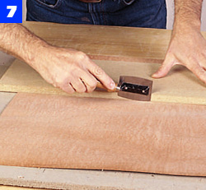
Use a veneer saw and straightedge guide to cut the veneers for the head-board and footboard panels.
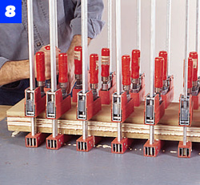
Clamp two veneered panels in a stack with cauls on the top and bottom. Apply clamps from the center toward the ends.
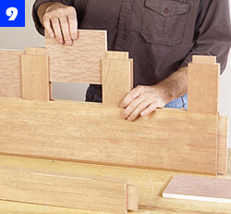
Apply glue to the joints and assemble the stiles and bottom rail. Slide the panels into place and add the top rail.
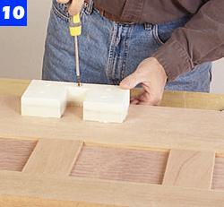
Make the poplar beam-support blocks. Bore pilot holes and screw them to the center of the front and back lower rails.
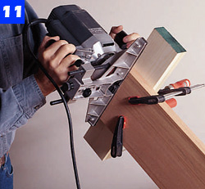
To rout the hanger mortises, clamp a board to the rail for router support. Use a small chisel to cut the deeper recesses.
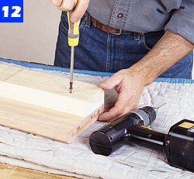
Locate the support-rail ends 1/16 in. short of the main rail ends. Then, screw the poplar support rails in place.
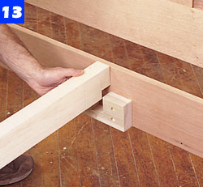
After engaging the side rails with the head- and footboards, slide the slat-support beam into position.
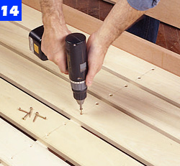
Check that the bed frame is square before installing the slats. Then, secure each slat with 1-1/2-in. No. 8 screws.

